**COMSATS University Islamabad, Abbottabad Campus**

**Department of Computer Science**

**Project Proposal**

**Bank Management System**

**CSC392 Object Oriented Software Engineering**

Submitted on: <24/04/22 >

Group Members:

Ahmed Bin Khalid (FA20-BSE-062)

Zain Asif (FA20-BSE-136)

Hassan Javed (FA20-BSE-143)

Rahim Durrani (FA20-BSE-050)

Muhammad Hashir (FA20-BSE-079)

Ghulam Abbass (FA20-BSE-053)

Mubashir Ahmed (FA20-BSE-063)

…

Table of Contents

CHAPTER 1 PROJECT PROPOSAL 5

Introduction 5

Vision and Business Case 5

VISION 5

Business Case 5

Use-Case Model 6

Supplementary Specification 6

Glossary 6

Risk List & Risk Management Plan 7

CHAPTER 2 USE CASES 8

Use Case Diagram 9

Brief Level Use Cases 10

AHMED BIN KHALID (FA20-BSE-062) 10

Use Case 1: Sign Up 10

Use Case 2: Log In 10

Use Case 3: Get Reports 10

Fully Dressed Use Cases 11

AHMED BIN KHALID (FA20-BSE-062) 11

Use Case UC 2: Log In 13

Use Case UC 3: Get Reports 16

20

Brief Level Use Cases 21

ZAIN ASIF (FA20-BSE-136) 21

Use Case 1: Deposit Funds 21

Use Case 2: Deposit Cash 21

Use Case 3: Deposit Cheque 21

Use Case 4: Withdraw Money 21

Brief Level Use Cases 21

Hassan Javed (FA20-BSE-143). 21

Use Case 2: Create Business Account. 22

Use Case 3: Create Student Account. 22

Use Case 4: Create Saving Account. 22

Fully Dressed Use Cases 23

ZAIN ASIF (FA20-BSE-136) 23

Use Case UC 1: Deposit Funds 23

Use Case UC 2: Deposit Slip 26

Use Case 3: Deposit Cheque 29

Use Case UC4: Withdraw Money 32

Hassan Javed (FA20-BSE-143). 34

Use Case 3: Create Student Account. 40

Use Case 4: Create Saving Account. 43

Rahim Khan [FA20-BSE-050] 46

Brief Use Case Diagram 46

Use case 3 : request 46

Use case 2 : types of insurance 47

Use case 3 : terms 47

**Use case name:** Insurance 47

MUBASHIR AHMED (FA20-BSE-063) 51

Use Case 1: Pay Bills 51

Use Case 2: Transfer Funds 51

Use Case 3: Inquiry of balance 51

Fully Dressed Use Cases 51

Mubashir Ahmed (FA20-BSE-063) 51

Use Case UC 1: Pay Bills 51

Use Case UC 2: Transfer Funds 54

Use Case 3: Balance Inquiry 57

CHAPTER 2 USE CASES 59

Use Case Diagram 59

Brief Level Use Cases 59

Student Name: Ghulam Abbas (FA20-BSE-053) 59

HASHIR 079 68

# CHAPTER 1 PROJECT PROPOSAL

## Introduction

**Banking System**

# The banking sector is the lifeline of any modern economy. It is one of the important financial pillars of the financial sector, which plays a vital role in the functioning of an economy. It is very important for economic development of a country that it’s financing requirements of trade, industry and agriculture are met with higher degree of commitment and responsibility. Thus, the development of a country is integrally linked with the development of banking. In a modern economy, banks are to be considered not as dealers in money but as the leaders of development.

# They play an important role in the mobilization of deposits and disbursement of credit to various sectors of the economy. The banking system reflects the economic health of the country. The strength of an economy depends on the strength and efficiency of the financial system, which in turn depends on a sound and solvent banking system. A sound banking system efficiently mobilized savings in productive sectors and a solvent banking system ensures that the bank can meet its obligation to the depositors.

In this project, we are to develop the banking system along with all the possible use cases, brief level use cases, fully dressed use cases and GUI interfaces.

The project is divided into 8 members of the group with a workload of almost three to four use cases to design and implement.

## Vision and Business Case

## VISION

Is the most complicated software system which aims at the professional management of the clients activities in the bank and a quick access to clients account database.

With the rapid development of IT sector, high quality banking system has become extremely important, in the modern world there is a hardly a single person that is not involved into the banking, naturally everyone has an account in the bank and saves his money there, it is pretty much obvious that everyone wants to have a constant access to his financial accounts but this is not possible without a high quality banking system already but she didn't.

## Business Case

Availability of this system 24/7 is very much crucial for the client function. for this purpose, we're designed a banking management system that able to provide high quality access to clients database

The proposed banking management system will be having four types of accounts, business account, current account, saving account and student account.

The proposed banking system will have the payment system of the following.

* Utilities payment
* Education payment
* Government payment

The proposed banking system will have the capability to create insurances and life insurance is, this will give the client accessibility make insurances on the go. Other than that property insurance system will enable the client to insure their properties 24/7 with the proposed management system.

## Use-Case Model

Describes the functional requirements. During inception, the names of most use cases will be identified, and perhaps 10% of the use cases will be analyzed in detail.

## Supplementary Specification

* Process authorization response within 10 seconds 90% of the time during sign up and log in.
* If the client enters to get report for sign up, he will have to approve it with his CNIC.
* If the user enters to override any information during sign up, he will get fail and will be shown a warning.
* If the client enters the wrong CNIC or not write it properly during login the system show the message to the client to write it properly.
* If the client chooses a weak password the system will not register him until a strong and secure password is being chosen by the client and shows the message of weak password to the user.
* Touch screen UI on a large flat panel monitor. Text must be visible from 10 meter.
* Only one customer can withdraw money 50,000 thousand rupees at a time.
* If system crashes, it will automatically restart within 30 second.
* Money cannot be deposit if the customer is not given the proper detail of his accounts. To solve this the system must gave the user another slips the rewrite the information again.
* If the customer balance history is not good, then his insurance can’t be done, and his request will be not denied.
* During bill payments if the Customer pays the bill without a customer detail, the top payment will be marked with the reference number.
* During funds transferred money cannot be transferred if the customer is not given the proper detail of his accounts to were transfer money.

***Describes other requirements, mostly non-functional. During inception, it is useful to have some idea of the key non-functional requirements that have will have a major impact on the architecture.***

[Textbook: 7.4. NextGen Example: (Partial) Supplementary Specification]

## Glossary

***Key domain terminology, and data dictionary.***

7.8. NextGen Example: A (Partial) Glossary

## Risk List & Risk Management Plan

Just like any business, banks face a myriad of risks. However, given how important the banking sector is and the government’s stake in keeping risks in check, the risks weigh heavier than they do on most other industries? There are various types of risks that a bank may face and is important to understand how banks manage risk.

**Common Risks That Bank Face are Following**

**Banking Risk#1:**

Banks often lend out money. The chance that a loan recipient does not pay back that money can be measured as credit risk. This can result in an interruption of cash flows, increased costs for collection, and more.

Credit risk mitigation refers to the actions taken by lenders to reduce the probability of non-payment by borrowers There are several safeguards that lenders take to mitigate risks Inadequate risk mitigation can adversely impact lender’s balance sheet and profits Banks and other types of lending institutions use various strategies to mitigate credit risk such as the 5 Cs of credit, risk-based pricing, contractual debt covenants, post-disbursement monitoring, and limiting sectoral exposure

**Banking Risk#2:**

This refers to the risk of an investment decreasing in value because of market factors (such as a recession). Sometimes this is referred to as “systematic risk.”

Because the risk affects the entire market, it cannot be diversified to be mitigated but can be hedged for minimal exposure. As a result, investors may fail to earn expected returns despite the rigorous application of fundamental and technical analysis on the particular investment option. The VaR method is a standard method for the evaluation of market risk. VaR technique is a risk management method that involves the use of statistics that quantifies a stock or portfolio’s prospective loss, as well as the probability of that loss occurring. Although it is widely utilized, the VaR method requires some assumptions that limit its accuracy. The beta coefficient enables an investor to measure how volatile the nature or market risk of a portfolio or security is, in comparison to the rest of the market

**Banking Risk#3:**

These are potential sources of losses that result from any sort of operational event; e.g., poorly-trained employees, a technological breakdown, or theft of information.

Four Steps that will tell you how to Reduce Operational Risk:

Step 1: Managing Equipment Failures.

Step 2: Keep Strong Business to Business Relationships.

Step 3: Having Adequate Insurance.

Step 4: Know the Regulations.

**Banking Risk#4:**

Let’s say a news story breaks about a bank having corruption in leadership. This may damage their customer relationships, cause a drop in share price, give competitors an advantage, and more.

Following are some ways to reduce corruption risks

* Update anti-bribery & anti-corruption policies.
* Get the tone right from the top.
* Embed ABAC principles in corporate culture.
* Ensure gifts & hospitality meet key criteria.
* Conduct due diligence on all third parties.
* Watch out for bribery & corruption red flags.

**Banking Risk#5:**

With any financial institution, there is always the risk that they are unable to pay back its liabilities in a timely banner because of unexpected claims or an obligation to sell long term assets at an undervalued price.

To be able to mitigate such risks banks simply use hedging contracts. They use financial derivatives which are freely available for sale in any financial market. Using contracts like forwards, options and swaps, banks can almost eliminate market risks from their balance sheet.

# CHAPTER 2 USE CASES

## Use Case Diagram

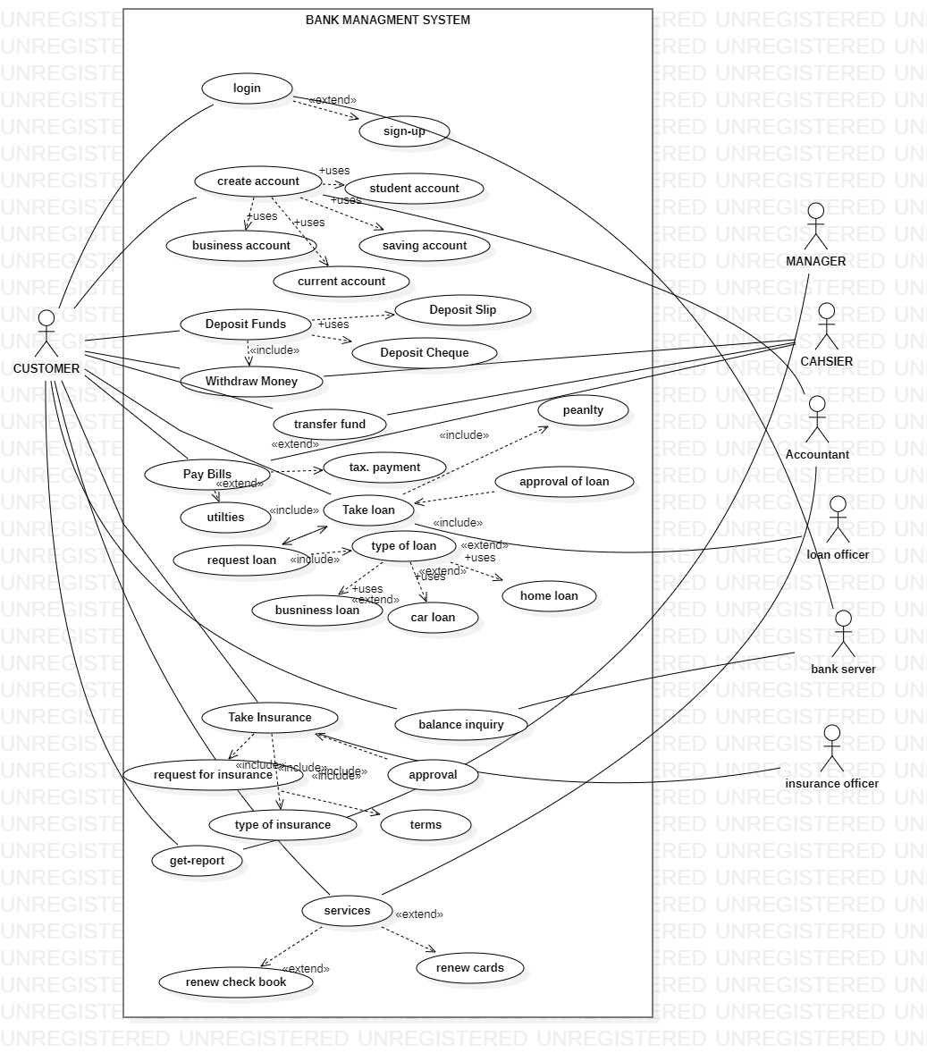

## Brief Level Use Cases

### AHMED BIN KHALID (FA20-BSE-062)

| Use Case 1: Sign Up |
| --- |

The client arrives at the bank to get facilitate. Prior to every act he will have to sign up in the banking system if he didn’t register himself before. The sign-up page requires the CNIC number and ask to create and confirm a password for yourself. As he gets himself register now, he can log in into the system as the bank server added him to avail different facilities offered by the banking system.

### Use Case 2: Log In

The client tries to log in first as soon as he arrives at the bank. Only those can log in into the bank who had registered themselves before with their CNIC number and password for themselves. The Log in page requires to enter the CNIC number and password he chosen at the time of Sign up to recall him from the bank server. As he enters the required information now he can log in into the system.

### Use Case 3: Get Reports

The user of the bank arrives at the bank. As the bank has already provided him and manager the option to get reports. To do so he just need to apply for get reports which includes the transaction history (deposit history, withdraw history), card used history, the times of log in and history every facility the bank offers. The client and the manager both can check it.

| Fully Dressed Use CasesAHMED BIN KHALID (FA20-BSE-062) **Use Case UC 2: Sign Up**  **Use Case Section**  Comments |
| --- |
| **Use Case Name**  Sign Up |
| **Scope** |
| **Level**  Banking Management System |
| **Stakeholders and Interests**  **User**: The client wants to get himself register in the bank so he can get facilitate by the bank.  **Bank server**: the bank server records the data of the client so that he can log in him next time through his CNIC and password he chooses. |
| **Preconditions**  CNIC is must |
| **Success Guarantee**   * The Client enters the required information and get himself register in the system. * After the first time the client now log in into the system directly. * The customer accesses the system and get facilitations according to will in banking system. |
| **Main success scenarios**   * The user connects to the Banking system. * The user enters his/her CNIC and password. * The system validates the CNIC and password. * The system determines the user’s account. * The bank again shows him the log in page where he can log in now as he registered himself in the sign-up section. |
| **Exceptions**   * If the client enters the wrong CNIC or not write it properly the system shows the message to the client to write it properly. * If the client chooses a weak password the system will not register him until a strong and secure password is being chosen by the client and shows the message of weak password to the user. |
| **Special Requirements**   * Process authorization response within 10 seconds 90% of the time. * Language internationalization on the text displayed. E.g., Urdu, English etc. * Touch screen UI on a large flat panel monitor. Text must be visible from 10 meter. * Only one customer can withdraw money 50,000 thousand rupees at a time. * If system crashes, it will automatically restart within 30 second. |
| **Frequency of Occurrences**  They will occur only onetime as the client tries to get himself register. |
| **Miscellaneous**   * How many bank accounts can be register on one CNIC? * How can the client below 18 can register themselves? |

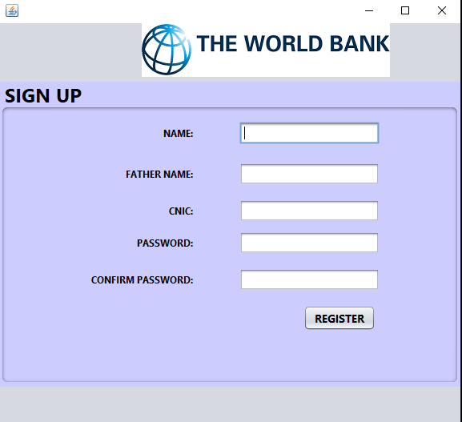

| Use Case UC 2: Log In |
| --- |
|  |

**Use Case Section**

Comments

**Use Case Name**

Log In

**Scope**

Banking Management System

**Level**

The client goal is to log in into the system.

**Primary Actor**

Customer, Bank server

**Stakeholders and Interests**

**User**: The user tries to log in into the system to facilitate him with the banking system.

**Bank Server**: The bank server let him log in into the system as he get himself registered before during the time of sign up.

**Preconditions**

CNIC is must

**Success Guarantee**

* The user enters the CNIC and password.
* The Bank server validates the information.
* The customer access the system and get facilitations according to will in banking system.

**Main success scenarios**

* The user connects to the Banking system.
* The user enters his/her CNIC and password.
* The system validates the CNIC and password.
* The system determines the user’s account.
* The system displays a list of actions the user can perform based on the user’s role.

**Exceptions**

* If the client enters the wrong CNIC or not write it properly the system shows the message to the client to write it properly
* If the user enters the worn g password three times, he will get the message of getting his/her account is blocked.
* In case of wrong password or forgetting the password, the user can get the hint to remember his password.

**Special Requirements**

* Process authorization response within 10 seconds 90% of the time.
* Language internationalization on the text displayed. E.g. Urdu, English etc.
* Touch screen UI on a large flat panel monitor. Text must be visible from 10 meter.
* Only one customer can withdraw money 50,000 thousand rupees at a time.
* If system crashes, it will automatically restart within 30 second.

**Technology and Data variations List**

* The use can choose the forget password to change it again.
* The client can get hint as he forgets his password to log in again.
* A message always showing to some extent in order of weak password.

**Frequency of Occurrences**

This step occurs every time the client tries to get into the system.

**Miscellaneous**

* What happens if client forgets his/her password?
* What happens if he gets himself block for providing the wrong information.

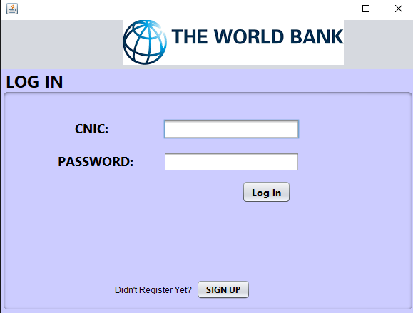

| Use Case UC 3: Get Reports |
| --- |

**Use Case Section**

Comments

**Use Case Name**

Get Reports

**Scope**

Banking Management System

**Level**

The client goal and manager’s goal is to get reports.

**Primary Actor**

Customer, Bank server, Manager

**Stakeholders and Interests**

**User**: The user tries to get report from the system to facilitate him with the banking system.

**Bank Server**: The bank server generates the report for the manager and the client so that he can get the history.

**Manager:** The manager also can get the reports to have a check and balance and to know is there any special case to treat specially.

**Preconditions**

The client must have any type of account registered to his/her name.

**Success Guarantee**

* The user/manager tries to get the reports.
* The Bank server validates the information.
* The customer accesses the reports and get facilitations according to will in banking system.

**Main success scenarios**

* The user connects to the Banking system.
* The user/manager tries to get reports.
* The system validates the person requesting for reports.
* The system determines the user’s account.
* The system displays actions in term of reports to the user/ the manager.

**Exceptions**

* If the client enters to get report, he will have to approve it with his CNIC.
* If the user enters to override any information, he will get fail and will be shown a warning.
* In case of manager if he finds anything wrong, he can override it with the proper protocol.

**Special Requirements**

* Process authorization response within 10 seconds 90% of the time.
* Language internationalization on the text displayed. E.g. Urdu, English etc.
* Touch screen UI on a large flat panel monitor. Text must be visible from 10 meter.
* Only one customer can withdraw money 50,000 thousand rupees at a time.
* If system crashes, it will automatically restart within 30 second.

**Technology and Data variations List**

* The use can choose to report in term of any file type or as a print.
* The client can get it in the language he u understand well.
* The time of reports generated history will also be added after ever act of reports he perform.

**Frequency of Occurrences**

This step occurs every time the client tries to get reports from the system.

**Miscellaneous**

* What happens if the client has conflict with the generated report?
* What happens if the manager override the report without the proper protocol.

## 

## Brief Level Use Cases

### ZAIN ASIF (FA20-BSE-136)

### Use Case 1: Deposit Funds

A customer arrives at a bank with money to deposit. The cashier uses the Banking Management System to record each transection of deposited money. The system presents a running total deposited money. The Customer provide his/her information. The Cashier enters account information, which the system validates and records. The system updates transection. The customer receives a receipt from the system and then leaves the bank.

### Use Case 2: Deposit Cash

A customer arrives at a bank with money to deposit. As the bank have already provided him with the facility of deposit slip .The cashier uses the Banking Management System to record each transection of deposited money the Customer will fill his/her deposit slip .Customer will hand-over the slip to the cashier, the cashier will recount the money to verify the amount is correct. The system validates and records. The Customer has successfully deposited money in his account through slip. . The customer receives a receipt from the system and then leaves the bank.

### Use Case 3: Deposit Cheque

A customer arrives at a bank with money to deposit. As the bank have already provided him with the facility of deposit money by cheque. The cashier uses the Banking Management System to record each transection of deposited money the Customer will fill his/her deposit Cheque .Customer will hand-over the Cheque to the cashier, the cashier will recount the money to verify the Cheque and money. The system validates and records. The Customer has successfully deposited money in his account through Cheque. . The customer receives a receipt from the Bank and then Customer leaves the bank.

### Use Case 4: Withdraw Money

A customer arrives at a bank to withdraw money. The cashier uses the Banking Management System to record the withdraw process. The system presents a user detail and total money in account. The Customer provide his/her information. The Cashier enters account information, which the system validates and records. The system updates transection. Customer successfully withdraw money. The customer receives a receipt of transection from the system and then leaves the bank.

## Brief Level Use Cases

### Hassan Javed (FA20-BSE-143).

#### Use Case1: Create Account.

A customer arrives at a bank with its valid CNIC card and some useful information to make his account. Accountants collect all details from customer and request the system to make new account. System approves the request. Accountant feed all the customer information into the system. System verifies the customer information using biometric authorization services. Accountant saves the information into the system. System presents account receipt. Customer leaves bank with receipt and goods (if any).

### Use Case 2: Create Business Account.

A customer arrives at the bank with its Valid CNIC card and Valid Business Details to make his business account. Accountants collect the Business and personal details from customer and request the system to make a business account. System approves the request. Accountant feed all details (Business and personal) in the system. System verifies these details using biometric authorization services and verification code sent to customer business's phone number or email address. Accountant saves the customer Information (Business and personal) into the system. System presents account receipt. Customer leaves bank with receipt and goods (if any).

### Use Case 3: Create Student Account.

A customer arrives at a bank with its valid CNIC card and some valid studentship Information to make his student account. Accountants collect all details (personal and studentship) from customer and request the system to make new student account. System approves the request. . Accountant feed all the customer information (personal and studentship) into the system. System verifies the customer information using biometric authorization service and student online studying platform. Accountant saves the information into the system. System presents account receipt. Customer leaves bank with receipt and goods (if any).

### Use Case 4: Create Saving Account.

A customer arrives at a bank with its valid CNIC card and some financial Information to make his saving account. Accountants collect all details (personal and financial) from customer and request the system to make new saving account. System approves the request. Accountant feed all the customer information (personal and financial) into the system. System verifies the customer information using biometric authorization service. Accountant saves the information into the system. System presents account receipt. Customer leaves bank with receipt and goods (if any).

## Fully Dressed Use Cases

### ZAIN ASIF (FA20-BSE-136)

| | Use Case UC 1: Deposit Funds | | --- | | **Scope**: Banking Management System  **Level**: The Customer goal is to deposit money. It could be through deposit slip or Cheque Book.  **Primary** **Actor**: Customer ,Cashier | |
| --- | --- | --- |

**Success Guarantee** (or Post conditions):

Deposit money is saved. Deposit money is correctly calculated and deposited. Customer account is updated. Receipt is generated. Deposit authorization approvals are recorded.

**Main Success Scenario (or Basic Flow):**

1. Customer arrives at bank to deposit.
2. Cashier starts a new payee.
3. Customer provide his/her information.
4. Cashier enters Customer information.
5. Cashier repeats counting deposited money.
6. System presents total with previous money in account.
7. Cashier tells Customer the total.
8. System records deposit process.
9. Cahier Generated receipt and gave it to Customer.
10. Customers get receipt.
11. Customer leaves the bank.

**Extensions (or Alternative Flows)**

*a. At any time, System fails:

To support recovery and correct accounting, ensure all transaction sensitive state and events can be recovered from any step of the scenario.

1. Cashier restarts System and requests recovery of prior state.
2. System reconstructs prior state.

2a. System detects anomalies preventing recovery:

* 1. System signals error to the Cashier, records the error, and enters a clean state.
  2. Cashier starts a new payee.

*money is deposit without a detail:

Will we develop some conditions that puts each deposit in wrapping?

1. If the Customer deposit without a customer detail, the top payment will be marked with the account number.
2. The Customer only provide his account id to deposit money in account

*clothier Currency is Deposit

Deposit other currency in bank account. If the Bank Customer deposit other currency it cannot detect it. Your country currency will be marked and the others not.

1. To deposit foreign currency in your account you need to deposit foreign currency.
2. Our system provides the facility to deposit any currency in money it will automatically change into your country currency.

**Special Requirements:**

* Process authorization response within 40 seconds 70% of the time.
* Language internationalization on the text displayed. E.g., Urdu, English etc.
* Touch screen UI on a large flat panel monitor. Text must be visible from 10 meter.
* Only one customer can deposit money at a time.
* If system crashes, it will automatically restart within 30 second.

**Technology and Data Variations List**:

* The Deposit money is counted by banknote Counter.
* Identified Currency by FoxPro software.
* Customer always use the biometric fingerprint scanner to verify the transection every time he /she deposit money.
* Deposit Money through third party system.

**Open Issues:**

* What are the taxes that will apply on my account through the year?
* Explore the remote service recovery issue.
* Must a cashier take their cash drawer when they log out?
* Can the Other customer directly use the system to deposit money, or does the accountant have to do it?

**Screen Shots:**

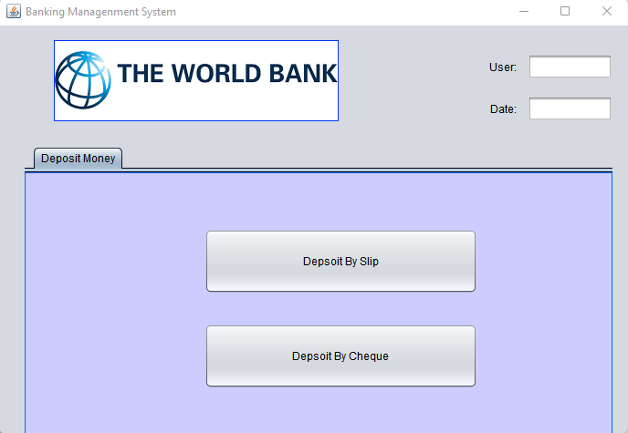

| | Use Case UC 2: Deposit Slip | | --- |   **Scope**: Banking Management System  **Level**: The Customer successfully deposit money in his account through deposit slip.  **Primary** **Actor**: Customer ,Cashier  **Stakeholders and Interests**:   * Cashier: Wants accurate, fast entry, and no deposit Payment errors, as cash drawer shortages are deducted from his/her salary. * Customer: Wants deposit and fast service with minimal effort. Wants easily in depositing money in his account. Wants proof of payment to support his side. * Bank Manager: Wants to accurately record transactions and satisfy customer interests. Wants to ensure that Payment Authorization Service payment receivables are recorded. * Maintenance: Wants to be able to quickly perform override operations, and easily debug Cashier, accountant, manager problems. * Bank Server: Wants to receive correct digital transection requests in the correct format and protocol. Wants to accurately store the transection history in the server.   **Preconditions**:  Customer must have a Bank account to deposit money and Cashier is identified and authenticated. |
| --- | --- |

**Success Guarantee** (or Post conditions):

Deposit money is saved. Deposit money is correctly calculated and deposited. Customer account is updated. Receipt is generated. Deposit authorization approvals are recorded.

**Main Success Scenario (or Basic Flow):**

1. Customer arrives at bank to deposit money.
2. Cashier starts a new payee.
3. Customer enters Customer information in a deposit slip.
4. Customer gave slip to cashier.
5. Cashier counted deposited money
6. System records deposit process and presents total with previous money in account.
7. Cashier generates receipt.
8. Customers get receipt and leave the bank.

**Extensions (or Alternative Flows):**

*a. At any time, System fails:

To support recovery and correct accounting, ensure all transaction sensitive state and events can be recovered from any step of the scenario.

1. Cashier restarts System and requests recovery of prior state.
2. System reconstructs prior state.

2a. System detects anomalies preventing recovery:

* 1. System signals error to the Cashier, records the error, and enters a clean state.
  2. Cashier starts a new payee.

*b. Money cannot deposit with Wrong detail:

If the Customer deposit with wronged customer details, the top payment will not be marked.

* Money cannot be deposit if the customer is not given the proper detail of his accounts. To solve this the system must gave the user another slips the rewrite the information again

1. The System must open his domain open for all type of given information I.e.
2. Customer Name Must be of 15 Character.
3. Write the Correct Date.
4. Authorize your slip with the sign of accountant.

*c. Accountant Sign:

If the accountant sign is not present on the slip them the customer cannot deposit money.

To solve the issue

1. The user first authorizes the slip from accountant
2. then gave the cashier to deposit money

**Special Requirements:**

* Process authorization response within 10 seconds 90% of the time.
* Language internationalization on the text displayed. E.g., Urdu, English etc.
* Touch screen UI on a large flat panel monitor. Text must be visible from 10 meter.
* Only one customer can deposit money at a time.
* If system crashes, it will automatically restart within 30 second.

**Technology and Data Variations List**:

* The Deposit money is counted by banknote Counter.
* Identified Currency by FoxPro software.
* Customer always use the biometric fingerprint scanner to verify the transection every time he /she deposit money.
* Deposit Money through third party system.

**Open Issues:**

* What are the taxes that will apply on my account through the year?
* Explore the remote service recovery issue.
* Must a cashier take their cash drawer when they log out?
* Can the Other customer directly use the system to deposit money, or does the accountant have to do it?

**Screen Shots:**

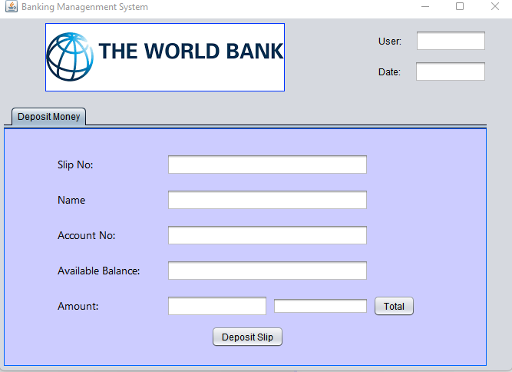

| Use Case 3: Deposit Cheque |
| --- |
| **Scope**: Banking Management System  **Level**: The Customer successfully deposit money in his account through Cheque.  **Primary** **Actor**: Customer ,Cashier  **Stakeholders and Interests**:   * Cashier: Wants accurate, fast entry, and no deposit Payment errors, as cash drawer shortages are deducted from his/her salary. * Customer: Wants deposit and fast service with minimal effort. Wants easily in depositing money in his account. Wants proof of payment to support his side. * Bank Manager: Wants to accurately record transactions and satisfy customer interests. Wants to ensure that Payment Authorization Service payment receivables are recorded. * Maintenance: Wants to be able to quickly perform override operations, and easily debug Cashier, accountant, manager problems. * Bank Server: Wants to receive correct digital transection requests in the correct format and protocol. Wants to accurately store the transection history in the server.   **Preconditions**:  Customer must have a Bank account to deposit money and Cashier is identified and authenticated. |

**Success Guarantee** (or Post conditions):

Deposit money is saved. Deposit money is correctly calculated and deposited. Customer account is updated. Receipt is generated. Deposit authorization approvals are recorded.

**Main Success Scenario (or Basic Flow):**

1. Customer arrives at bank to deposit money.
2. Cashier starts a new payee.
3. Customer enters Customer information in a deposit slip.
4. Customer gave slip to cashier.
5. Cashier counted deposited money
6. System records deposit process and presents total with previous money in account.
7. Cashier generates receipt.
8. Customers get receipt and leave the bank.

**Extensions (or Alternative Flows):**

*a. At any time, System fails:

To support recovery and correct accounting, ensure all transaction sensitive state and events can be recovered from any step of the scenario.

1. Cashier restarts System and requests recovery of prior state.
2. System reconstructs prior state.

2a. System detects anomalies preventing recovery:

* 1. System signals error to the Cashier, records the error, and enters a clean state.
  2. Cashier starts a new payee.

*b. At any time, System fails:

To support recovery and correct accounting, ensure all transaction sensitive state and events can be recovered from any step of the scenario.

1. Cashier restarts System, logs in, and requests recovery of prior state.
2. System reconstructs prior state.

2a. System detects anomalies preventing recovery:

* 1. System signals error to the Cashier, records the error, and enters a clean state.
  2. Cashier starts a new sale.

1a. Customer wants to resume a suspended Cheque.

1. Cashier performs resume operation and enters the ID to retrieve the process.
2. System displays the state of the resumed process, with subtotal and total money.

2a. Cheque not found.

* 1. System Internet Connection error to the Cashier.
  2. Cashier starts new payee and customer re-enters all his/her detail.

**Special Requirements:**

* Process authorization response within 10 seconds 90% of the time.
* Language internationalization on the text displayed. E.g., Urdu, English etc.
* Touch screen UI on a large flat panel monitor. Text must be visible from 10 meter.
* Only one customer can deposit money at a time.
* If system crashes, it will automatically restart within 30 second.

**Technology and Data Variations List**:

* Cheque identifier id no entered by keyboard.
* Cheque payment signature captured on paper receipt.
* The Deposit money is counted by banknote Counter.
* Identified Currency by FoxPro software.

**Open Issues:**

* What is the Cheque duration to Deposit Money?
* What customization is needed for different accounts?

**Screen Shots:**

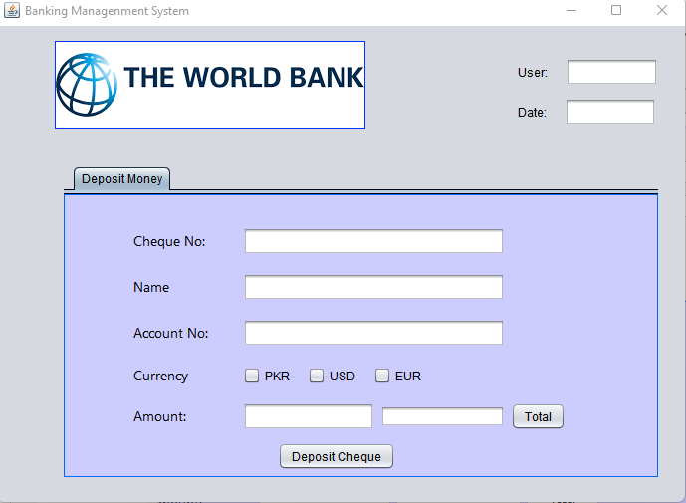

| Use Case UC4: Withdraw Money |
| --- |
| **Scope**: Banking Management System  **Level**: The Customer goal is to Withdraw money from his/her account.  **Primary** **Actor**: Customer ,Cashier  **Stakeholders and Interests**:   * Cashier: Wants accurate, fast entry, and no withdraw Payment errors, as cash drawer shortages are deducted from his/her salary. * Customer: Wants to withdraw and fast service with minimal effort. Wants easily in withdrawing money in his account. Wants proof of payment to support his side by receipt. * Bank Manager: Wants to accurately record transactions and satisfy customer interests. Wants to ensure that Payment Authorization Service payment receivables are recorded. * Maintenance: Wants to be able to quickly perform override operations, and easily debug Cashier, accountant, manager problems. * Bank Server: Wants to receive correct digital transection requests in the correct format and protocol. Wants to accurately store the transection history in the server.   **Preconditions**:  Customer must have a Bank account and have some deposit money in account and Cashier is identified and authenticated. |

**Success Guarantee** (or Post conditions):

Transection is saved. Withdraw money is successfully received. Customer account is updated. Receipt is generated. Withdraw authorization approvals are recorded.

**Main Success Scenario (or Basic Flow):**

1. Customer arrives at bank to withdraw money.
2. Cashier starts a new payee.
3. Customer provide his/her information.
4. Cashier enters Customer information.
5. Customers enter the amount to be withdrawn
6. Cashier repeats counting withdraw money.
7. System presents total with previous money in account.
8. System records Withdraw process.
9. Cashier Generated receipt and gave it to Customer.
10. Customers get receipt and leaves the bank

**Extensions (or Alternative Flows):**

*a. At any time, Manager requests an override operation:

1. System enters Manager-authorized mode.
2. Manager or Cashier performs one Manager-mode operation. e.g., cash balance change, resume a suspended sale on another register, void a sale, etc.
3. System reverts to Cashier-authorized mode.

*b. At any time, System fails:

To support recovery and correct accounting, ensure all transaction sensitive state and events can be recovered from any step of the scenario.

1. Cashier restarts System, logs in, and requests recovery of prior state.
2. System reconstructs prior state.

2a. System detects anomalies preventing recovery:

* 1. System signals error to the Cashier, records the error, and enters a clean state.
  2. Cashier starts a new sale.

1a. Customer or Manager indicate to resume a suspended payment.

1. Cashier performs resume operation and enters the account ID to retrieve the sale.
2. System displays the state of the resumed process, with subtotal.

2a. payment not found.

* 1. System signals error to the Cashier.
  2. Cashier starts new payee and re-write again withdraw method.

**Special Requirements:**

* Process authorization response within 10 seconds 90% of the time.
* Language internationalization on the text displayed. E.g., Urdu, English etc.
* Touch screen UI on a large flat panel monitor. Text must be visible from 10 meter.
* Only one customer can withdraw money 50,000 thousand rupees at a time.
* If system crashes, it will automatically restart within 30 second.

**Technology and Data Variations List**:

* The Withdraw money is counted by banknote Counter.
* Customer always use the biometric fingerprint scanner to verify the transection every time he /she Withdraw money.
* Withdraw Money through third party system.

.

**Screen Shots:**

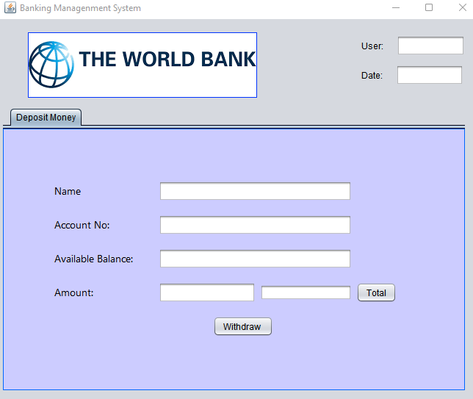

**Fully Dressed Use Cases**

### Hassan Javed (FA20-BSE-143).

#### Use Case1: Create Account.

**Scope**: Banking Management System.

**Level**: Creating an account in bank.

**Primary** **Actor**: Customer.

**Stakeholders and Interests**:

- Customer: Wants to create an account in bank to fulfil all its needs.

- Government Tax Agencies: wants to collect tax from customers and bank on creation of every new account in bank.

- Bank: wants to save the information and money of all its customers and fulfil all the needs of its customers.

-Guardians: wants to manage the account if suddenly any unnecessary event occurred with the customer.

-Accountant: wants to collect all useful information from customer and feed it into the system to make its account in bank.

- Biometric Authorization Service: wants to receive biometric request from Accountant and verify the Customer Information.

**Preconditions**:

Customer age must above 18 years and must have valid CNIC card. Customer must at least have some money to manage its checkbook and ATM card after creating an account in bank.

**Success Guarantee** (or Post conditions):

Customer Information is saved into the system. Verification is completed successfully .customer's guardian is set successfully. Account is successfully created.

**Main Success Scenario (or Basic Flow):**

1. A customer arrives at a bank with its valid CNIC card and some useful information to make his account.
2. Accountant collects CNIC card and useful information from customer and request the system to make an account.
3. System approves the request and display the application form to create an account
4. Accountants use the customer information to fill the application form and verify the customer information through biometric authorization services.
5. System will be verifying the customer Information and display on screen that verification is completed.
6. Accountant set the Guardians of customer to manage the account if an un-necessary event occurred with customers.
7. Accountant will save the Customer Information into the system.
8. System will Display on screen that account has been created successfully and present account receipt.
9. Accountant will print the receipt and give to customer.
10. Customer leaves with receipt and goods (if any).

**Extensions (or Alternative Flows):**

**a*.** If System fails to verify Customer Information using biometric authorization services.

Use email or phone number to verify customer account Information.

**b*.** IfSystem fails to save Customer Information.

Accountants use auto fill option to use Current Information about customer and resave it.

**c*.** IfSystem fails to show the account application form.

Accountant re-send request to system to display account application form.

**Special Requirements:**

* System must save the customer information within 10 seconds.
* System must have capabilities to verify customer Information within 20 seconds.
* Language Internationalization on the text displayed.
* Auto fill the account Application form with current Information if system will fail to save the customer Information.

**Technology and Data Variations List**:

* System verifies customer information using biometric authorization services.
* System also have capability to verify customer Information using email and Phone Number.

**Open Issues:**

* What the laws and taxes will be applied on Customer and bank while creating an account.
* Fine will be applied if customer have lost his account details.

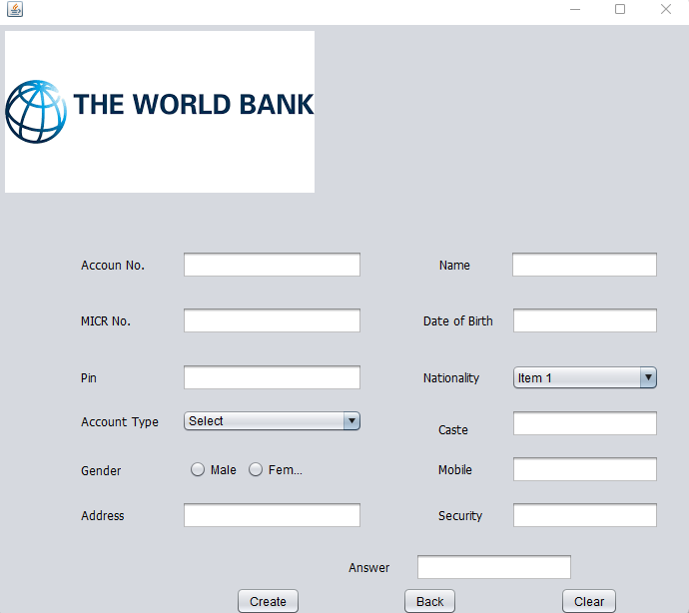**Screenshot**

#### Use Case2: Create Business Account.

**Scope**: Banking Management System.

**Level**: Creating a business account in bank.

**Primary** **Actor**: Customer.

**Stakeholders and Interests**:

- Customer: Wants to create a business account in bank to fulfil all its Business needs.

- Government Tax Agencies: wants to collect tax from customers and bank and make check balance on creation of every new Business account in bank.

- Bank: wants to save the information and money of all its customers and Business Account and fulfil all the needs of its customers.

Online Business Tracking System: wants to track Business Details of Customer who wants to create a Business account in bank.

-Guardians: wants to manage the account if suddenly any unnecessary event occurred with the customer.

-Accountant: wants to collect all useful information from customer and feed it into the system to make its business account in bank.

- Biometric Authorization Service: wants to receive biometric request from Accountant and verify the Customer Information.

**Preconditions**:

Customer must have its own business to create a Business account in bank. Customer age must above 18 years and must have valid CNIC card. Customer must at least have 20 transactions per month in a Bank.

**Success Guarantee** (or Post conditions):

Customer Business is tracking successfully through online tracking system. Customer Information is saved into the system. Verification is completed successfully .customer's guardian is set successfully. Business Account is successfully created.

**Main Success Scenario (or Basic Flow):**

1. A customer arrives at a bank with its valid CNIC card Valid Business Details to make his business account.
2. Accountants collect the Business and personal details from customer and request the system to make an account.
3. System approves the request and display the Business account application form to create a business account
4. Accountants use the customer information to fill the application form and verify the customer information through Online Business Tracking System and biometric authorization services
5. System will display on screen that verification is completed.
6. Accountant set the Guardians of customer to manage the account if an un-necessary event occurred with customers.
7. Accountant will save the Customer Information into the system.
8. System will Display on screen that Business account has been created successfully and present account receipt.
9. Accountant will print the receipt and give to customer.
10. Customer leaves with receipt and goods (if any).

**Extensions (or Alternative Flows):**

**a*.** If System fails to verify Customer Information using Online Business Tracking System.

Accountants use his business details to verify from some other corporation.

**b*.** IfSystem fails to save Customer Information.

Accountants use auto fill option to use Current Information about customer and resave it.

**c*.** IfSystem fails to show the Business account application form.

Accountant re-send request to system to display Business account application form.

**Special Requirements:**

* System must have capability to verify the customer business details.
* System must save the customer information within 10 seconds.
* System must have capabilities to verify customer Information within 20 seconds.
* Language Internationalization on the text displayed.
* Auto fill the account Application form with current Information if system will fail to save the customer Information.

**Technology and Data Variations List**:

* System must verify customer business details using online business tracking system.
* System must have capability to send verification code to confirm account is created or not.
* System verifies customer personal Information using biometric authorization services.
* System also have capability to verify customer Information using email and Phone Number.

**Open Issues:**

* Very large amount of taxes is applied on every transaction of Business account.
* Fine will be applied if customer have lost his account details.
* Check balance are applied on business account from Government tax agencies.

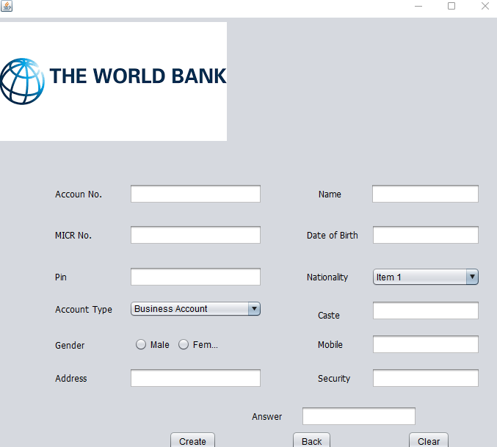**Screenshot.**

### Use Case 3: Create Student Account.

**Scope**: Banking Management System.

**Level**: Creating a student account in bank.

**Primary** **Actor**: Customer.

**Stakeholders and Interests**:

- Customer: Wants to create a student account in bank to fulfil all its Study and other needs.

- Government Tax Agencies: wants to collect low amount of tax from customers and bank on creation of every new student account in bank.

- Bank: wants to save the information and money of all its customers and fulfil all the needs of its customers.

-Guardians: wants to manage the account if suddenly any unnecessary event occurred with the customer.

-Accountant: wants to collect all useful information from customer and feed it into the system to make its Student Account in bank.

- Biometric Authorization Service: wants to receive biometric request from Accountant and verify the Customer Information.

**Preconditions**:

Customer must be a student to create a Business account in bank. Customer age must above 18 years and must have valid CNIC card.

**Success Guarantee** (or Post conditions):

Customer studentship is successfully checked. Customer Information is saved into the system. Verification is completed successfully .customer's guardian is set successfully. Student Account is successfully created.

**Main Success Scenario (or Basic Flow):**

1. A customer arrives at a bank with its valid CNIC card some Studentship Details to make his student account.
2. Accountants collect the Studentship and personal details from customer and request the system to make student account.
3. System approves the request and display the student account application form to create a student account
4. Accountants use the customer information to fill the application form and verify the customer information through biometric authorization services
5. System will display on screen that verification is completed.
6. Accountant set the Guardians of customer to manage the account if an un-necessary event occurred with customers.
7. Accountant will save the Customer Information into the system.
8. System will Display on screen that Student account has been created successfully and present account receipt.
9. Accountant will print the receipt and give to customer.
10. Customer leaves with receipt and goods (if any).

**Extensions (or Alternative Flows):**

**a*.** If System fails to verify Customer Information using Biometric Authorization services.

Accountants use verification code system to verify customer Information.

**b*.** IfSystem fails to save Customer Information.

Accountants use auto fill option to use Current Information about customer and resave it.

**c*.** IfSystem fails to show the student account application form.

Accountant re-send request to system to display Student account application form.

**Special Requirements:**

* System must provide student account application form.
* System must have capability to verify the customer Information using Biometric Authorization services.
* System must use code verification technique if Biometric Authorization Service is not working.
* System must save the customer information within 10 seconds.
* System must have capabilities to verify customer Information within 20 seconds.
* Language Internationalization on the text displayed.
* Auto fill the account Application form with current Information if system will fail to save the customer Information.

**Technology and Data Variations List**:

* System must verify customer student details using online student ship platform.
* System verifies customer personal Information using biometric authorization services.
* System also have capability to verify customer Information using email and Phone Number.

**Open Issues:**

* Some Constraints are applied on the Functionalities of bank that cannot be used by student account customers.
* Fine will be applied if customer have lost his account details.
* Government taxes are applied while creating an account, but it is less.

**Screenshot.**

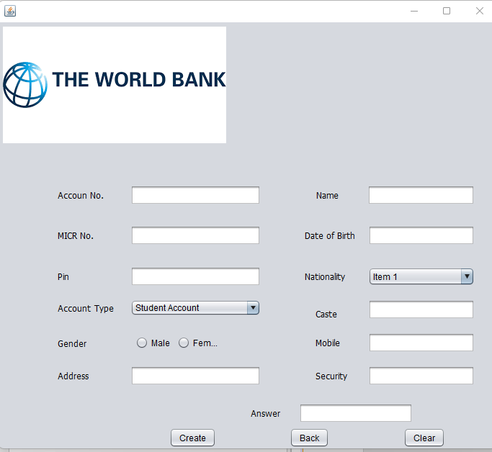

### Use Case 4: Create Saving Account.

**Scope**: Banking Management System.

**Level**: Creating a Saving account in bank.

**Primary** **Actor**: Customer.

**Stakeholders and Interests**:

- Customer: Wants to create a Saving Account in bank to fulfil its financial and other needs.

- Government Tax Agencies: wants to collect tax from customers and bank on creation of every new Saving Account in bank and collect taxes at the time of transactions and many other operations.

- Bank: wants to save the information and money of all its customers and fulfil all the needs of its customers.

-Guardians: wants to manage the account if suddenly any unnecessary event occurred with the customer.

-Accountant: wants to collect all useful information from customer and feed it into the system to make its Saving Account in bank.

- Biometric Authorization Service: wants to receive biometric request from Accountant and verify the Customer Information.

**Preconditions**:

Customer salary must be greater than 30000 to create a saving account in bank. Customer age must above 18 years and must have valid CNIC card.

**Success Guarantee** (or Post conditions):

Customer salary is successfully checked using its pay slip. Customer Information is saved into the system. Verification is completed successfully .customer's guardian is set successfully. Saving Account is successfully created.

**Main Success Scenario (or Basic Flow):**

1. A customer arrives at a bank with its valid CNIC card some Salary Details to make his saving account.
2. Accountants collect the Salary and personal details from customer and request the system to make saving account.
3. System approves the request and display the saving account application form to create a saving account
4. Accountants use the customer information to fill the application form and verify the customer information through biometric authorization services and also using its pay slip.
5. System will display on screen that verification is completed.
6. Accountant set the Guardians of customer to manage the account if an un-necessary event occurred with customers.
7. Accountant will save the Customer Information into the system.
8. System will Display on screen that Saving Account has been created successfully and present account receipt.
9. Accountant will print the receipt and give to customer.
10. Customer leaves with receipt and goods (if any).

**Extensions (or Alternative Flows):**

**a*.** If customer do not have its pay slip yet.

Account use the corporation details where it is worked to check its pay.

**b*.** IfSystem fails to save Customer Information.

Accountants use auto fill option to use Current Information about customer and resave it.

**c*.** IfSystem fails to show the Saving Account application form.

Accountant re-send request to system to display Saving Account application form.

**Special Requirements:**

* System must provide Saving Account application form.
* System must save the customer information within 10 seconds.
* System must have capabilities to verify customer Information within 20 seconds.
* Language Internationalization on the text displayed.
* Auto fill the account Application form with current Information if system will fail to save the customer Information.

**Technology and Data Variations List**:

* System must verify customer Salary details using online company employee searching system.
* System verifies customer personal Information using biometric authorization services.
* System also have capability to verify customer Information using email and Phone Number.

**Open Issues:**

* Zakat will deduct every year from saving account without the permission of customer.
* Fine will be applied if customer have lost his account details.
* Government taxes are applied while creating an account.

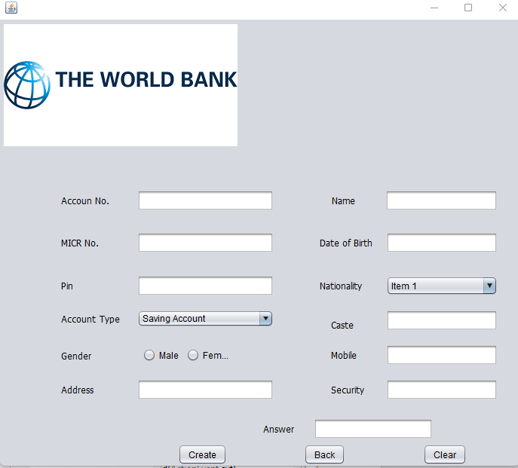**Screenshot.**

### Rahim Khan [FA20-BSE-050]

## Brief Use Case Diagram

## Use case 3 : request

When the customer arrives to the bank for insurance so he has first file a request for it with the help of loan officer and which is further transfer to accounts where they check your balance score and if everything is right your insurance will be completed

## Use case 2 : types of insurance

When the customer wants to apply for an insurance so he has to select that what he wants to insure like car, phone or health. So, the customer must have to choose a type of insurance

## Use case 3 : terms

For insurance, the customer has to agree the terms of that particular bank, like how he is going to pay his installments and in what case he may not be able to claim is insurance.

### **Use case name:** Insurance

**Scope:** Banking Management System

**Level**: the customer insurance is done.

**Primary Actor**: Customer, insurance officer

**Stakeholders and Interests:**

- Customer: Wants to get insurance for car, health etc.

-Loan Officer: He will explain different plans, offers to you, and complete your insurance.

- Deposit Authorization Service: Will check whether you are paying your installments on time or not.

**Preconditions:** User must pay the installments on time.

**Success Guarantee**: select the type of insurance you want, and the insurance will done.

**Main Success Scenario:**

1. Customer arrives at bank for insurance.
2. Insurance officers tell him about the plans.
3. Customer select the plan he wants.
4. Officer inquiries about his balance score.
5. If everything is okay, then the insurance is done.

**\*b. If the loan in not approved:**

If the customer balance history is not good, then his insurance can’t be done and his request will be not denied.

**Special Requirements:**

- Touch screen UI on a large flat panel monitor. Text must be visible from 1 meter.

- Process authorization response within 30 seconds 80% of the time.

- Somehow, we want robust recovery when access to remote services such the inventory system is failing.

- Language internationalization on the text displayed.

- Pluggable business rules to be insertable at steps 3 and 7

.

**Open Issues:**

- What are the tax law variations?

- Explore the remote service recovery issue.

- What customization is needed for different businesses?

- Must a cashier take their cash drawer when they log out?

- Can the customer directly use the card reader, or does the cashier have to do it?

**Screen Shots:**

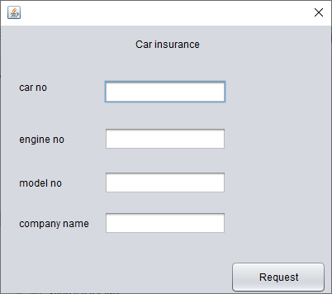

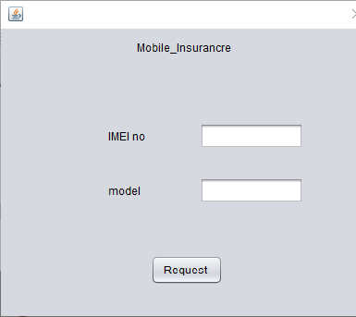

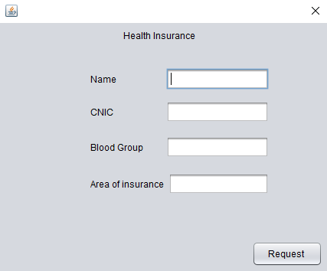

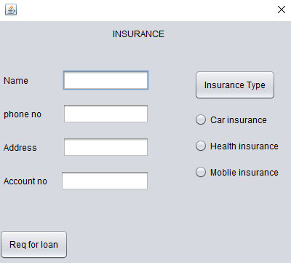

### 

### MUBASHIR AHMED (FA20-BSE-063)

### Use Case 1: Pay Bills

A customer arrives at a bank to pay the bill. The cashier uses the Banking Management System to record each transection of the bill . The system presents the detail of the bill. The Customer provide his/her bill. The Cashier enters the bill information, which the system validates and records. The system updates transection. The customer receives a receipt from the system and then leaves the bank.

### Use Case 2: Transfer Funds

A customer arrives at a bank to transfer the funds . As the bank have already provided him with the facility of depositing slip .The cashier uses the Banking Management System to record each transection of deposited money the Customer will fill his/her deposit slip to transfer funds .Customer will hand-over the slip to the cashier, the cashier will recount the money to verify the amount is correct. The system validates and records. The Customer has successfully transferred money in the account through slip. . The customer receives a receipt from the system and then leaves the bank.

### Use Case 3: Inquiry of balance

AA customer arrives at the bank to check his funds. As the bank has many employees who have access to check the balance. The representee uses the banking management system to check the balance of the customer by inputting his account no. the officer confirms the account name of the customer, then tells him the balance

## Fully Dressed Use Cases

### Mubashir Ahmed (FA20-BSE-063)

| | Use Case UC 1: Pay Bills | | --- | | **Scope**: Banking Management System  **Level**: The Customer goal is to pay the bills. It could be through deposit slip or Cheque Book.  **Primary** **Actor**: Customer ,Cashier  **Preconditions**: Customer identification is verified through his identity card | |
| --- | --- | --- |

**Success Guarantee** (or Post conditions):

* Billing information is saved in the system.
* Bill amount is generated to the cashier he counts the money and deposits in the company account with reference no of customer bill.

**Main Success Scenario (or Basic Flow):**

* Cashier arrives at the bank to deposit the bill amount.
* Cashier starts a new payment
* Cashier takes bill from customer
* Cashier enters customer bill reference no in the system
* Cashier enters the customer information in the system
* Cashier takes money from customer and counts it
* Cashier approves the bill and submits it
* Cashier prints the payment information on the bill
* Customer leaves the bank

**Extensions (or Alternative Flows)**

**Case A: Incase System Fails**

To support recovery and correct accounting, ensure all transaction sensitive state and events can be recovered from any step of the scenario.

* Cashier restarts System and requests recovery of prior state.
* System reconstructs prior state.

**2a. System detects anomalies preventing recovery:**

* + System signals error to the Cashier, records the error, and enters a clean state.
  + Cashier starts a new payee.

**\*Case B : If Bill Money is deposit without a detail:**

Will we develop some conditions that puts each deposit in wrapping?

* If the Cashier deposit bill money without a customer detail, the top payment will be marked with the customer cynic.
* The Customer only provide his id to deposit bill money.

**Special Requirements:**

* System takes less than 20 seconds to fetch the details of the bill
* System supports dual language i.e. Urdu sandhi pashto
* Text is clear and visible to the cashier
* Cashier can deposit more than one bill at once
* If the system crashes due to any error system will automatically save the details and restart from where it was left

**Technology and Data Variations List**:

* The customer counts the bill amount money
* Currency of amount is verified through a software
* Customer cynic is taken on depositing bill amount
* Depositing bill amount is done through apis

**Open Issues:**

* + How much tax will be applied to a customer after depositing certain amount bills during a single month
  + Recovery issues
  + Cashier must count the notes during depositing bill and makes sure its depositing with right detail
  + Can customer deposit the billing amounts remotely

**Screen Shots:**

| | Use Case UC 2: Transfer Funds | | --- |   **Scope**: Banking Management System  **Level**: Basic Goal  **Primary** **Actor**: Customer ,Cashier  **Stakeholders and Interests**:   * Cashier: wants to feed the data accurately so that there are payment errors. * Customer: wants to deposit the money in the account through less effort and making sure his payment is transferred properly. * Bank manager: wants his employees to make sure proper details are recorded in the system in case of any negligence he will be responsible * Bank Server: wants the system to be put data accurately with proper format.   **Preconditions**:   * Customer must have a bank account to transfer the funds and cashier verifies that account name and number and gives it go. * The customer must have a valid cnic card to carry this transaction * The customer must have a valid account number to carry the transition |
| --- | --- |

**Success Guarantee** (or Post conditions):

* Transferred money is saved.
* Transferred money is transferred to the desired to the desired account.
* Customer verifies the accounts.
* Receipt for transfer of funds is generated for the customer.

**Main Success Scenario (or Basic Flow):**

* Customer transfers the funds through slip or online
* System generates the confirmation slip for the customer
* Customer arrives at the bank to transfer the funds
* Cashier starts a new payment
* Customer enters the funds transfer details in deposit
* Customer gets receipt slip for transfer of funds and leaves bank

**Extensions (or Alternative Flows):**

**CASE A.: At any time, System fails:**

To support recovery and correct accounting, ensure all transaction sensitive state and events can be recovered from any step of the scenario.

* Cashier restarts System and requests recovery of prior state.
* System reconstructs prior state.

**2a. System detects anomalies preventing recovery:**

* System signals error to the Cashier, records the error, and enters a clean state.
* Cashier starts a new payee.

**CASE B: Money cannot transfer with Wrong detail:**

If the Customer transfers money with wronged details, the top payment will not be marked.

Money cannot be transferred if the customer is not given the proper detail of transfers. To solve this the system must gave the user another slips the rewrite the information again

* The System must open his domain open for all type of given information I.e.
* Transfer account Name Must be of 15 Character.
* Write the Correct Date.
* Authorize your slip with the sign of accountant.

**CASE C: Accountant Sign:**

If the accountant sign is not present on the slip them the customer cannot transfer money.

To solve the issue

* The user first authorizes the slip from accountant
* then gave the cashier to transfer money

**Special Requirements:**

* Process authorization response within 10 seconds 90% of the time.
* Language internationalization on the text displayed. E.g., Urdu, English etc.
* Touch screen UI on a large flat panel monitor. Text must be visible from 10 meter.
* Only one customer can deposit money at a time.
* If system crashes, it will automatically restart within 30 second.

**Technology and Data Variations List**:

* The transferred money is counted by banknote Counter.
* Identified Currency by FoxPro software.
* transferred Money through third party system.

**Open Issues:**

* What are the taxes that will apply on my account through the year?
* Explore the remote service recovery issue.
* Must a cashier take their cash drawer when they log out?
* Can the Other customer directly use the system to deposit money, or does the accountant have to do it?

**Screen Shots:**

| Use Case 3: Balance Inquiry |
| --- |
| **Scope**: Banking Management System  **Level**: The Customer successfully inquire the balance through account number  **Primary** **Actor**: Customer ,Cashier  **Stakeholders and Interests**:   * Bank Server: Bank Server must have stable internet connection for checking the balance of customer. * Bank Manager: Wants to accurately record transactions and satisfy customer interests. Wants to ensure that Payment Authorization Service payment receivables are recorded. * Maintenance: Wants to be able to quickly perform override operations, and easily debug Cashier, accountant, manager problems. * Bank Server: Wants to receive correct digital transection requests in the correct format and protocol. Wants to accurately store the transection history in the server. * Customer: The customer must have valid account number to check his balance.   **Preconditions**:  The customer must have valid account number to check his balance |

**Success Guarantee** (or Post conditions):

The customer must have valid account number to check his balance

**Main Success Scenario (or Basic Flow):**

* System shall show the details of the account funds through account number
* System should show the account holder name
* Customer arrives at bank to inquiry funds in his account.
* Customer enters Customer information to check the funds.

**Extensions (or Alternative Flows):**

**CASE A: At any time, System fails:**

To support recovery and correct accounting, ensure all transaction sensitive state and events can be recovered from any step of the scenario.

* + - Cashier restarts System and requests recovery of prior state.
    - System reconstructs prior state.

2a. **System detects anomalies preventing recovery:**

* + - System signals error to the Cashier, records the error, and enters a clean state.
    - Cashier starts a new payee.

**CASE B: At any time, System fails:**

To support recovery and correct accounting, ensure all transaction sensitive state and events can be recovered from any step of the scenario.

* + - Cashier restarts System, logs in, and requests recovery of prior state.
    - System reconstructs prior state.

2a. System detects anomalies preventing recovery:

* + - System signals error to the Cashier, records the error, and enters a clean state.
    - Cashier starts a new sale.

**Special Requirements:**

* Process authorization response within 10 seconds 90% of the time.
* Language internationalization on the text displayed. E.g., Urdu, English etc.
* Touch screen UI on a large flat panel monitor. Text must be visible from 10 meter.
* Only one customer can deposit money at a time.
* If system crashes, it will automatically restart within 30 second.

**Technology and Data Variations List**:

* Cheque identifier id no entered by keyboard.
* Cheque payment signature captured on paper receipt.
* The Deposit money is counted by banknote Counter.
* Identified Currency by FoxPro software.

**Open Issues:**

* What is the Cheque duration to Deposit Money?
* What customization is needed for different accounts?

**Screen Shots:**

# CHAPTER 2 USE CASES

## Use Case Diagram

<Paste your semester project diagram imported from CASE Tool i.e., strum here>

## Brief Level Use Cases

### Student Name: Ghulam Abbas (FA20-BSE-053)

#### Use Case1: Take loan

This use case is initiate when customer want to take loan. The customer visit the bank and ask the loan officer to check the type of loan. The loan officer guide about the loan types. After get the detail information about the loan types the he give application for loan and apply for more suitable or the most handful for him/her. The loan officer will check the customer income status if the condition fulfill the bank requirements of loan process then the loan process will be approved.

#### Use case2: Request for loan

This use case is initiate when customer submit their request for take loan. The loan officer checks the details of the assets of the customer to verify that he falls under the loan criteria or not.

#### Use case3: approval of loan

The use case is for the approval of the loan after checking all the details the loan officer will verify the details and give its approval after concerning the board director.

##### Student Name Ghulam Abbas (FA20-BSE-053)

###### Fully Dressed Use Case 01:

**Use case name:** Take loan

**Scope:** Bank Management System.

**Level:** Basic goal

**Primary Actors:** Customers.

**Stakeholder and interest:**

**Customer**: if customer need to get loan from bank for this purpose he check the type of loan and apply for the most suitable and easy access type to fulfill their needs.

**Loan Officer**: investigate and collect information about customer. Check customer income he or she is eligible for loan or not.

**Bank:**  the bank give loan to the customer to get interest.

**Precondition:**

Customer should have monthly income or he/she is financially able to pay the loan amount.

Signature of two witness is mandatory on the loan application form.

**Post condition:**

Loan application is accepted. Customer is informed about loan details. Amount payment authorization approvals are recorded.

If the customer never pay the loan amount in the specific duration 50% increment is add to the interest.

**Main successful scenario:**

* Customer visit the bank and ask about the type of loan.
* Loan officer guide the customer about the details of loan types.
* Customer give application for loan for and apply for more suitable or the most handful for him/her.
* The loan officer will check the customer income status if the condition fulfill the bank requirements of loan process then the loan process will be approved.
* Customer arrive at bank and get the loan amount.
* Loan officer entry the loan details giving date, paying date and duration of loan.

**Specials requirements:**

The loan staff should pay the amount to the customer at his home.

The loan staff should collect the interest amount from the customer home. There should be no need for customer to go bank and pay interest.

There should be online paying facility for customer to pay interest

**Screen Shots:**

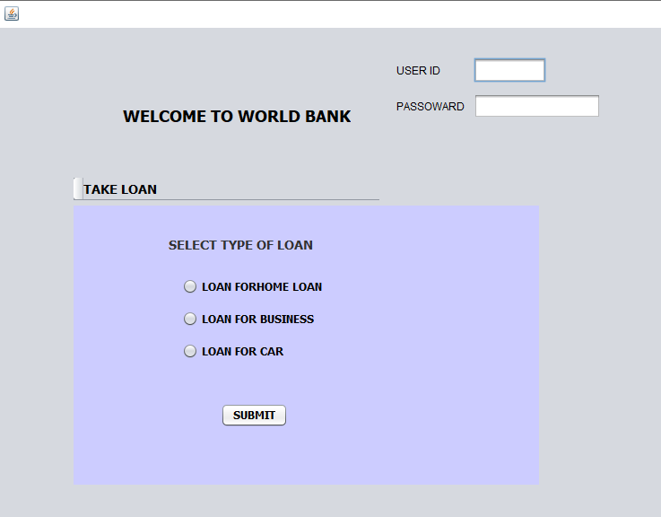

###### Fully Dressed use case 02:

**Use case name:** Request for loan

**Level:** User goal

**Scope:** Bank management system

**Primary Actor:**  customer

**Stakeholders and Interest:**

**-**Customer: customer go to the bank to request for take loan.

-loan officer: check the customer documents and process the loan application forward it to the manager.

-manager: Wants to be able to quickly perform override operations, and easily debug loan officer problems.

-Bank: Wants to accurately record transactions and satisfy customer interests. Wants to ensure that Payment Authorization Service payment receivables are recorded.

**Preconditions:**

Signature of two witness is mandatory on the loan application form.

Cashier is identified and authenticated.

**Post conditions:**

Loan request is saved. Interest is correctly calculated. Commissions recorded. Cheque or loan receipt is generated. Loan authorization approvals are recorded.

**Main successful scenario:**

* Customer arrives at Bank and request for loan.
* Loan officer check application and forward it to the manager.
* Manager quickly response to loan officer about the loan permission.
* Loan officer generate new loan file.
* Bank calculate the interest details.
* Casher give the amount to customer and guide him about interest and duration.
* Customer take the amount and leave the bank.

**Special requirements:**

The bank staff advertise about the loan there is no need for customer to arrives at the bank and request for loan.

Bank staff pay amount to the customer at his home.

There should be online system for requesting loan.

Loan should be deposit on customer account. Shouldn’t need for customer to arrive bank and get amount.

**Screen shot:**

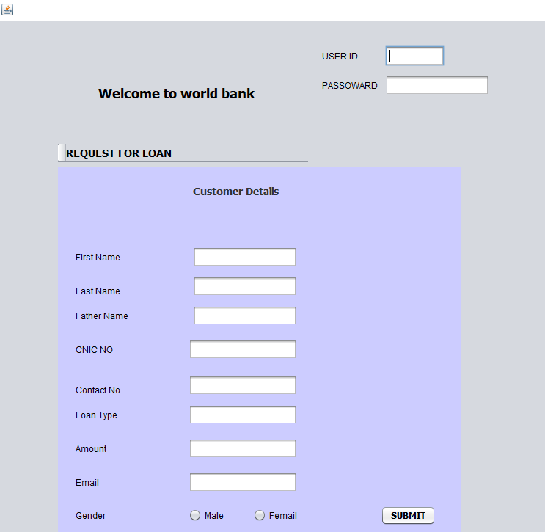

###### 

###### Fully dressed use case 03:

**Use case name:**  Approval of loan.

**Level:** user goal.

**Scope:** Bank management system

**Primary Actor:**  Customer

**Stakeholders and interest:**

* -customer: apply for loan and submit the required documents in the bank.
* -casher: check the application form and documents and forward the documents to the loan officer.
* -loan officer: verify the documents and customer status, income and his assets details.
* -bank: generate the interest rate for loan amount and duration of loan.

**Precondition:**

Loan officer verify the customer income documentations and employment status.

**Post condition:**

Loan documents approved. Interest is calculated and duration of loan is mention.

Loan authorization approvals are recorded.

Customer get loan amount.

**Main success scenario:**

1. Customer arrivers the bank and submit the documents for loan approval.
2. Casher collect the document and check the customer income status and assets details and forward the documents to the loan officer.
3. Loan officer verify the documents and approve the loan.
4. Bank calculate the interest rate of the loan and duration of loan.
5. Loan officer forward the approval letter to the casher to create a new loan file.
6. Casher create new file and mention customer details, amount, interest rate and loan duration.
7. Casher handover loan amount to the customer and the take signature of customer.
8. Customer cash amount and leave bank.

**Specials requirements:**

Online application approval system.

Minimum time required for approval system.

**Screen shot:**

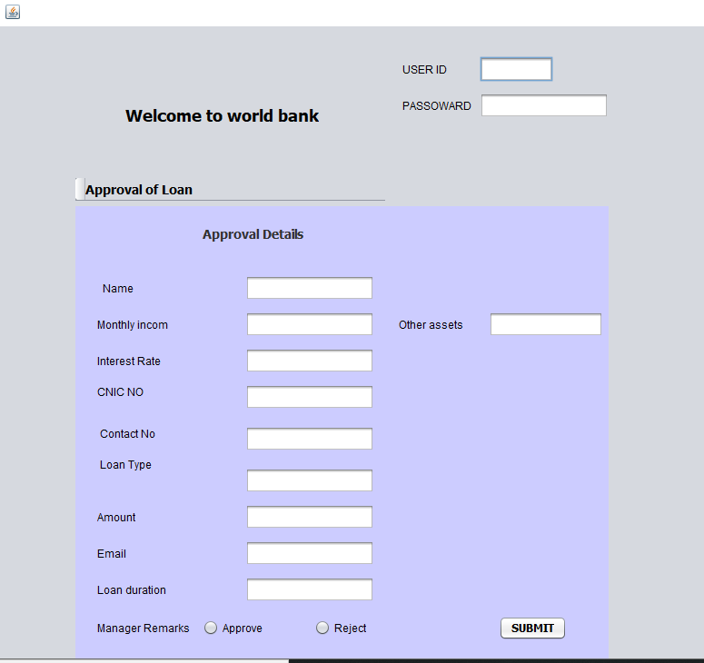

**Brief Use Case:**

**Use Case Name:**

Services

**Description:**

The customer of the bank uses services provided by the bank. Services include renew check book and renew cards. Services can also be checking accounts, wealth management system etc.

**Fully Dresses Use Case:**

**Use Case Name:**

Services

**Scope:**

Banking Management System

**Level:**

The customer goal is to use the services provided by the bank.

**Primary Actor:**

Customer, Accountant

**User:** The user tries the services provided by the bank.

**Accountant:** The accountant validates if the user’s desired services are correct and he/her account exits in the bank server.

**Preconditions:**

Account is must

**Success Guarantee:**

* The user gets into the banking system.
* The user goes into the services section.
* The system displays a list of services provided by the bank.

**Frequency of Occurrences:**

It’s up to the user.

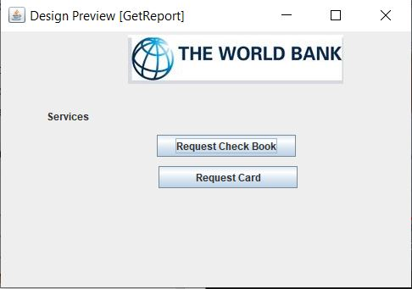

### HASHIR 079

**Brief Use Case:**

**Use Case Name:**

Renew Checkbooks

**Description:**

The user will request the accountant to renew checkbooks. The accountant will check the user’s account number and account and approve the request of the customer after looking after some more details about the customer. When all the conditions are valid customer will get their check books renewed.

**Fully Dressed Use Case:**

**Use Case Name:**

Renew Checkbooks

**Scope:**

Banking Management System

**Primary Actor:**

Customer, Accountant

**Preconditions:**

Account is must

**Success Guarantee:**

* Login to bank’s application with login pin and pin number
* Click on services
* Click on renew check book.
* Click on submit

**Main success scenario**

* The user logins to his/her account.
* The user clicks services.
* The user clicks renew check books.
* The system will send the information to the accountant.
* The accountant will reject or approve the request.

**Exceptions:**

* If the client enters the wrong check book number or not write it properly the system show the message to the client to write it properly.

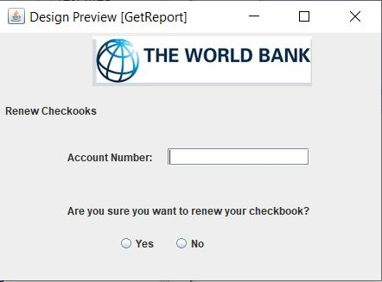

**Brief Use Case:**

**Use Case Name:**

Renew Cards

**Description:**

The customer will approach to the accountant and ask for card renewing. The accountant will ask for account number and card number. Accountant will submit information in the bank server for card renewing, then the customer receive the renewed card.

**Fully Dressed Use Case:**

**Use Case Name:**

Renew Card

**Scope:**

Banking Management System

**Primary Actor:**

Customer, Accountant

**Preconditions:**

Account is must

**Success Guarantee:**

* Login to bank’s application with login pin and pin number.
* Click on services.
* Click on renew cards.
* Click on submit

**Main success scenario**

* The user logins to his/her account.
* The user clicks services.
* The user clicks renew card.
* The system will send the information to the accountant.
* The accountant will reject or approve the request.

**Exceptions:**

* If the client enters the wrong card number or not write it properly the system show the message to the client to write it properly.

